Salesforce Expense Request Approval Process Setup Document  
Prepared By: Shaik Javeed Ahammad  
Project Title: Salesforce Expense Request Approval Process Setup  
Date: September 15, 2025

**1. Salesforce Org Preparation**

* Sign up for a Salesforce Developer Edition org, or log in to your company’s sandbox/production environment.
* Confirm that your user profile or assigned permission set includes “System Administrator” or the required permissions to create objects, fields, and automation.
* (Optional) Enable Lightning Experience for a modern interface and enhanced usability.

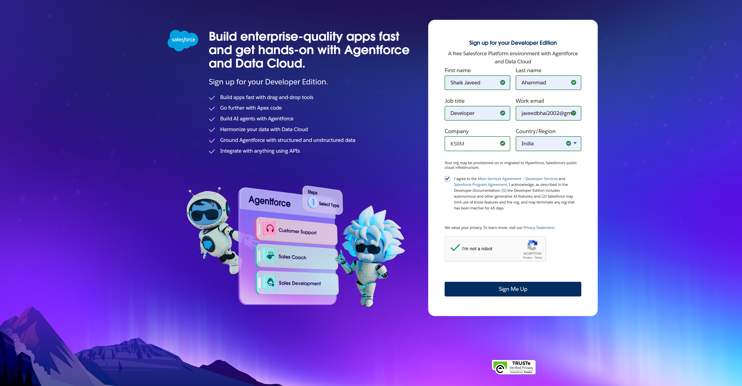

**2. Create Custom Objects**

**Expense Report**

* Path: Setup → Object Manager → Create → Custom Object
* Label: Expense Report
* Plural Label: Expense Reports
* Object Name: Expense_Report__c
* Record Name: Auto Number (Format: ER-{00000})
* Options: Enable for Reports, Activities, and Lightning Experience

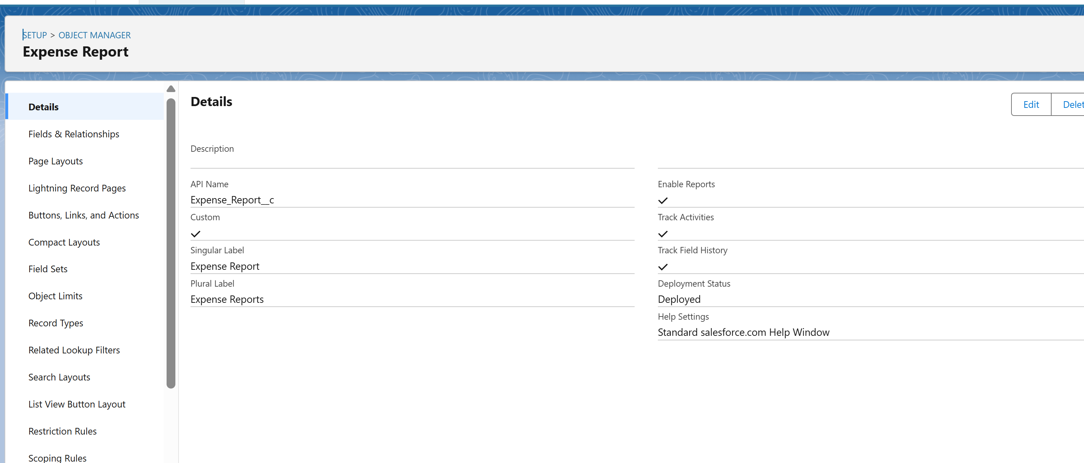

**Expense Item**

* Path: Setup → Object Manager → Create → Custom Object
* Label: Expense Item
* Plural Label: Expense Items
* Object Name: Expense_Item__c
* Record Name: Auto Number (Format: EI-{00000})
* Relationship: Master-Detail with Expense Report (parent)

**3. Custom Fields on Expense Report**

* **Submitter**: Lookup (User) → identifies the user submitting the report.
* **Status**: Picklist → Draft, Submitted, Approved, Rejected, Returned.
* **Total Amount**: Currency → Roll-up summary of related Expense Item amounts.
* **Start Date / End Date**: Date → span of expenses.
* **Submitted Date**: Date/Time → tracks when report enters approval process.
* **Description / Notes**: Long Text Area → stores additional details.
* **Approved By**: Lookup (User) → captures final approver.

**4. Custom Fields on Expense Item**

* **Type**: Picklist → Travel, Lodging, Meals, Other.
* **Amount**: Currency.
* **Expense Date**: Date.
* **Description**: Long Text Area.
* **Expense Report**: Master-Detail → links to parent Expense Report.

**5. Roll-Up Summary on Expense Report**

* Field: **Total Amount**
* Summarized Object: Expense Item
* Roll-Up Type: SUM of Amount field

**6. Create Tabs**

* Path: Setup → Tabs → Custom Object Tabs → New
* Create **Expense Report** tab
* Create **Expense Item** tab
* Assign tab styles and adjust visibility for selected profiles

**7. Next Steps (Optional)**

* Configure approval processes to automate routing and notifications.
* Add validation rules to maintain data quality.
* Customize page layouts and Lightning record pages for better user experience.
* Define permissions and sharing settings by role or profile.
* Build reports and dashboards for tracking expense submissions and approvals.

